**FUNCTIONAL AND TECHNICAL COMBINED DOCUMENTATION**

**Page (4) : Equity Portfolio ---🡪 Diversification (Front End Url :** <http://localhost:8100/page3/Page4>)

**Functional Picture:**

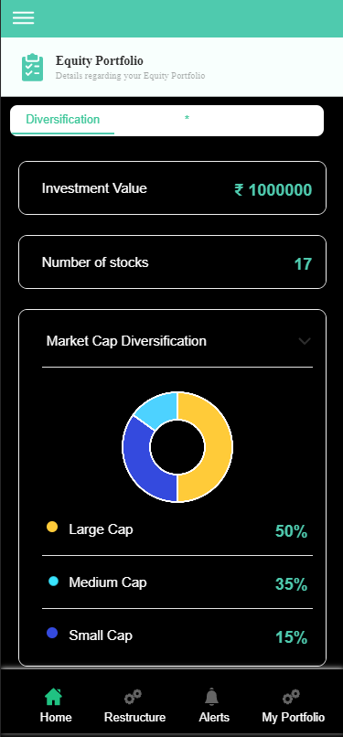

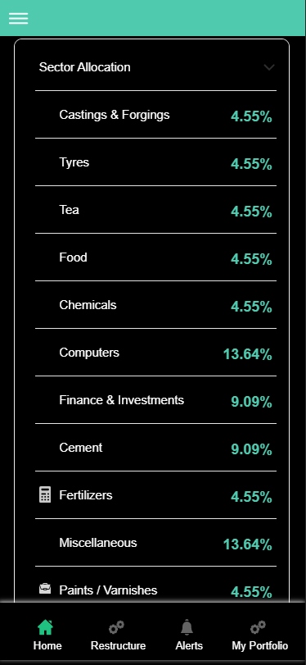

**Technical Explaination(Front End) :**

**In Page3.tsx, we are calling following two API’s:**

**1)** MarketCapWiseDiversificationAPI: see view.py python file from BackEnd

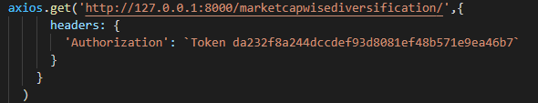

**2)** BuyFlagCalculationAPI: see view.py python file from BackEnd

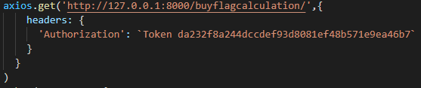

**As you can see above, there are two urls:**

* [**http://127.0.0.1:8000/marketcapwisediversification/**](http://127.0.0.1:8000/marketcapwisediversification/) **--🡪** MarketCapWiseDiversificationAPI
* [**http://127.0.0.1:8000/buyflagcalculation/**](http://127.0.0.1:8000/buyflagcalculation/) **--🡪** BuyFlagCalculationAPI

**From** MarketCapWiseDiversificationAPI, we are taking the data for the Pie Chart.

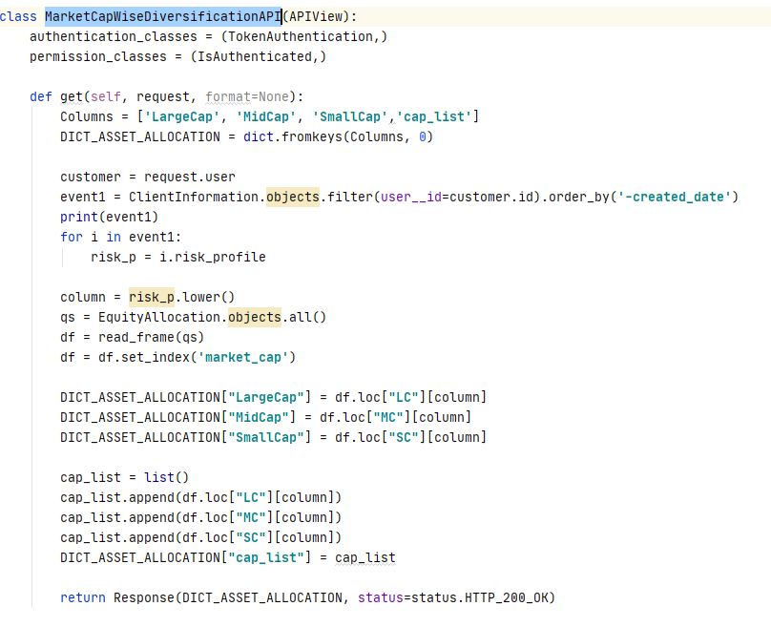

As you can see, we are taking the data for Pie chart from **EquityAllocation** database according to the risk profile.

**From** BuyFlagCalculationAPI, we are taking the data for following things:

* **Investment Value**
* **Number of Stocks**
* **Sector Allocation**

**For Investment Value :**



**We are taking the data from “ClientInformation” database**

**For Number of Stocks:**

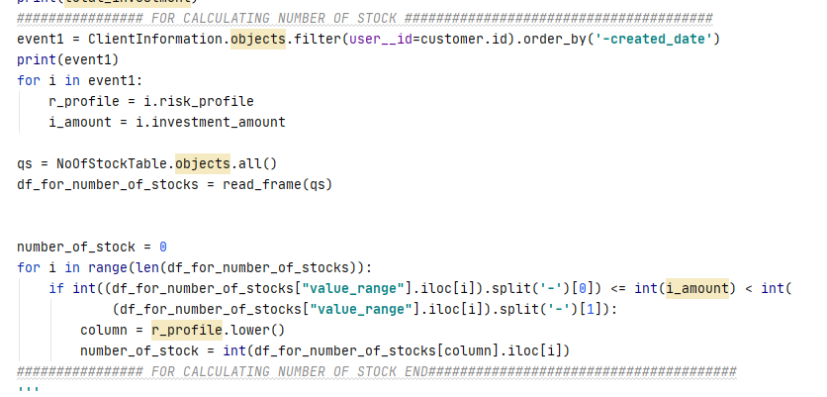

**We are calculating the number of stocks with the help of “risk_profile” and “investment_amount” value taken from “ClientInformation” Database and thereby calculating the number of stocks by looping through the “NoOfStockTable” database.**

**For Sector Allocation: Kindly see the below code where we are calculating the unique sectors and their percentages according to our “Buy Flag” recommendation.**

